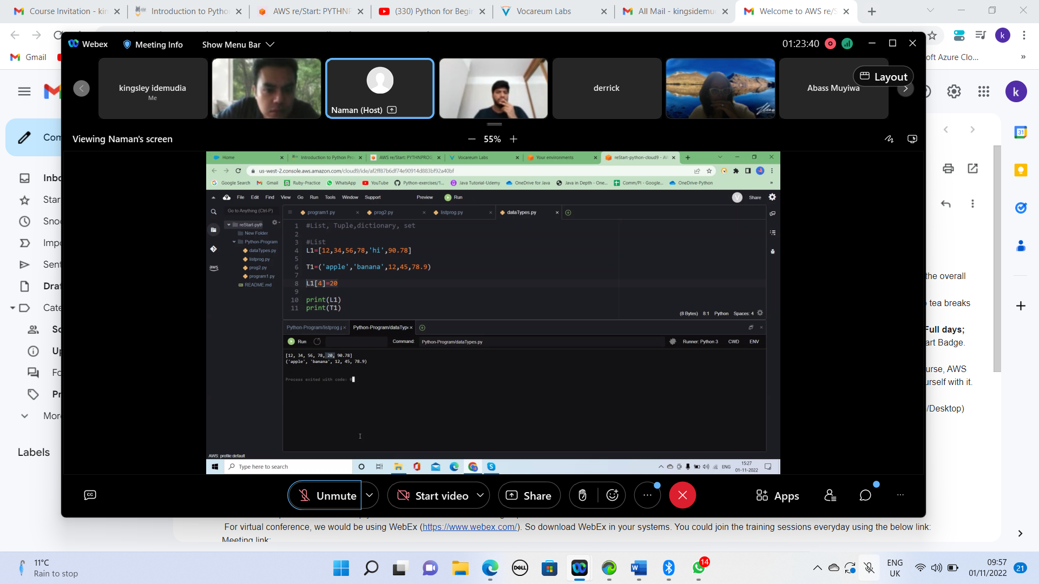

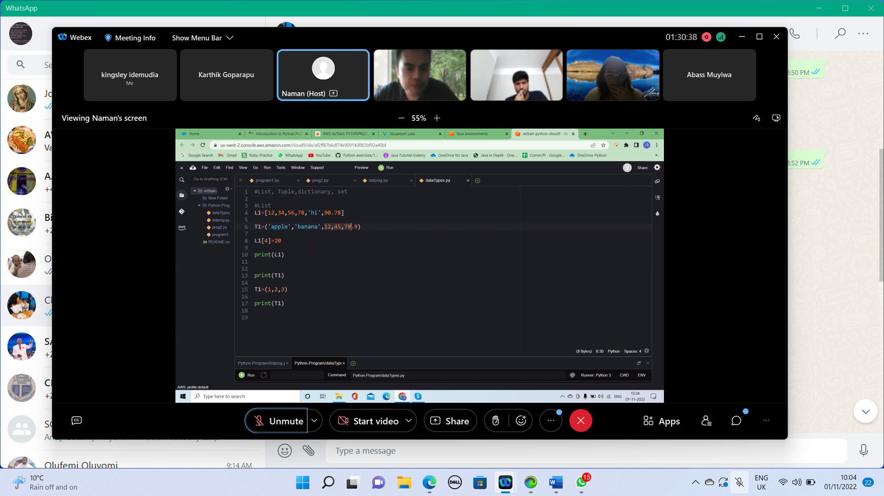

Check id

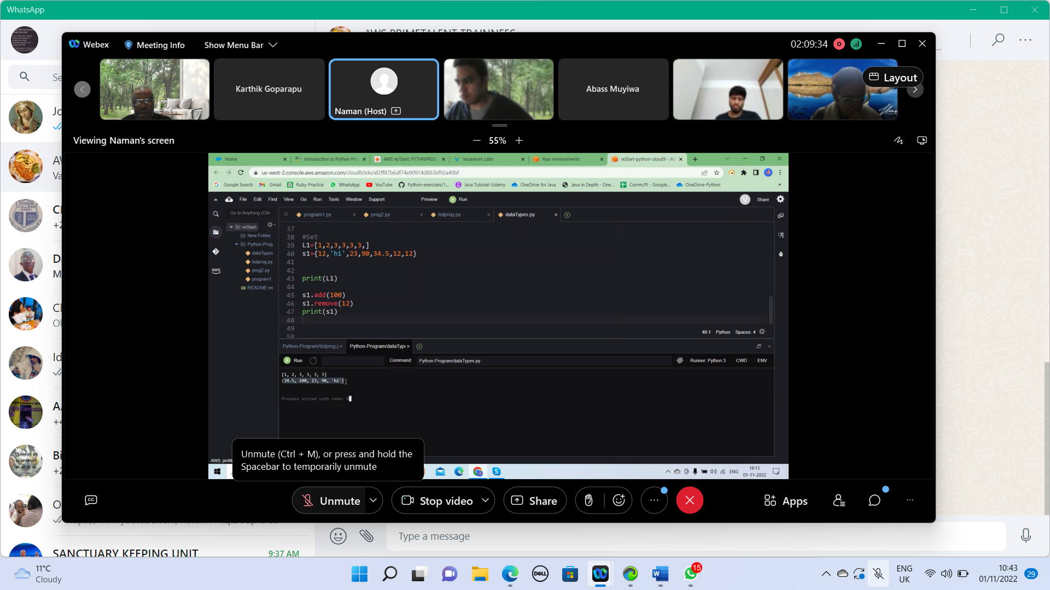

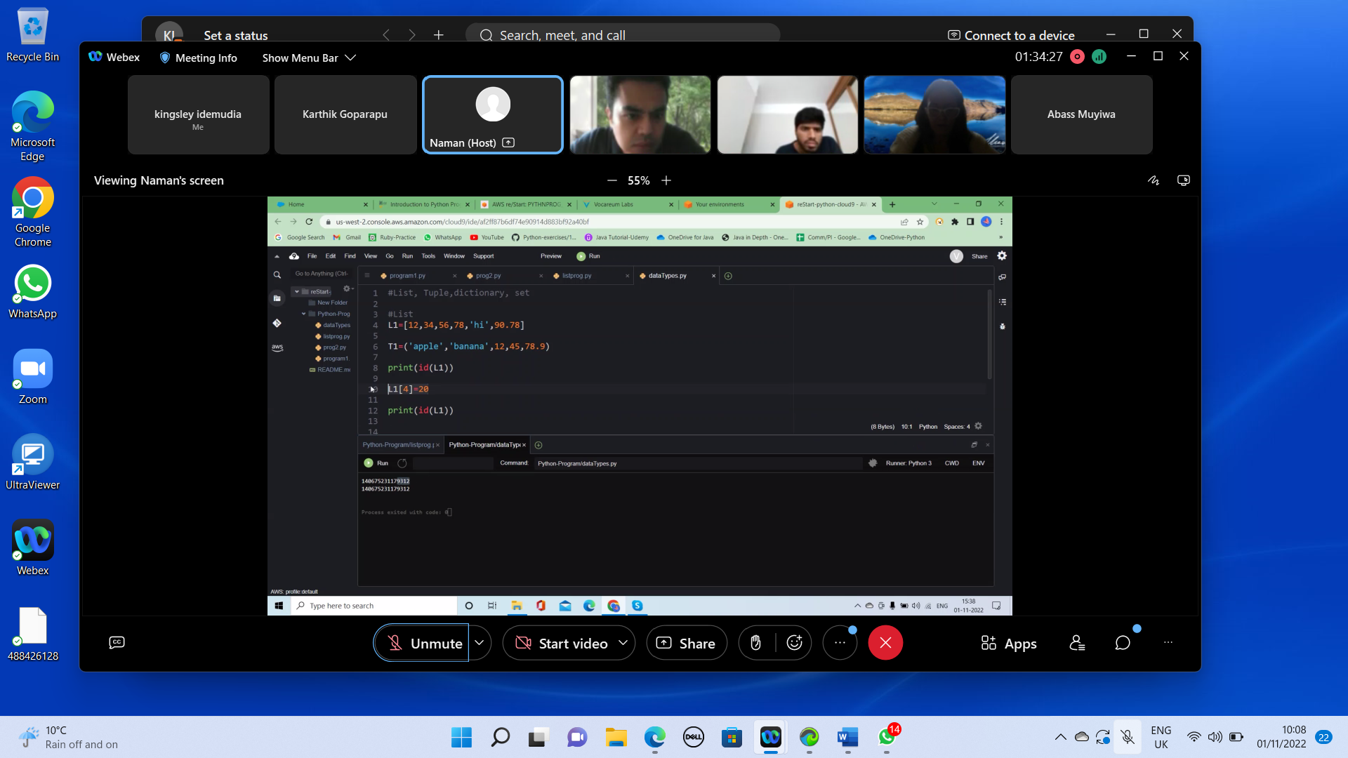

Plus demonstration

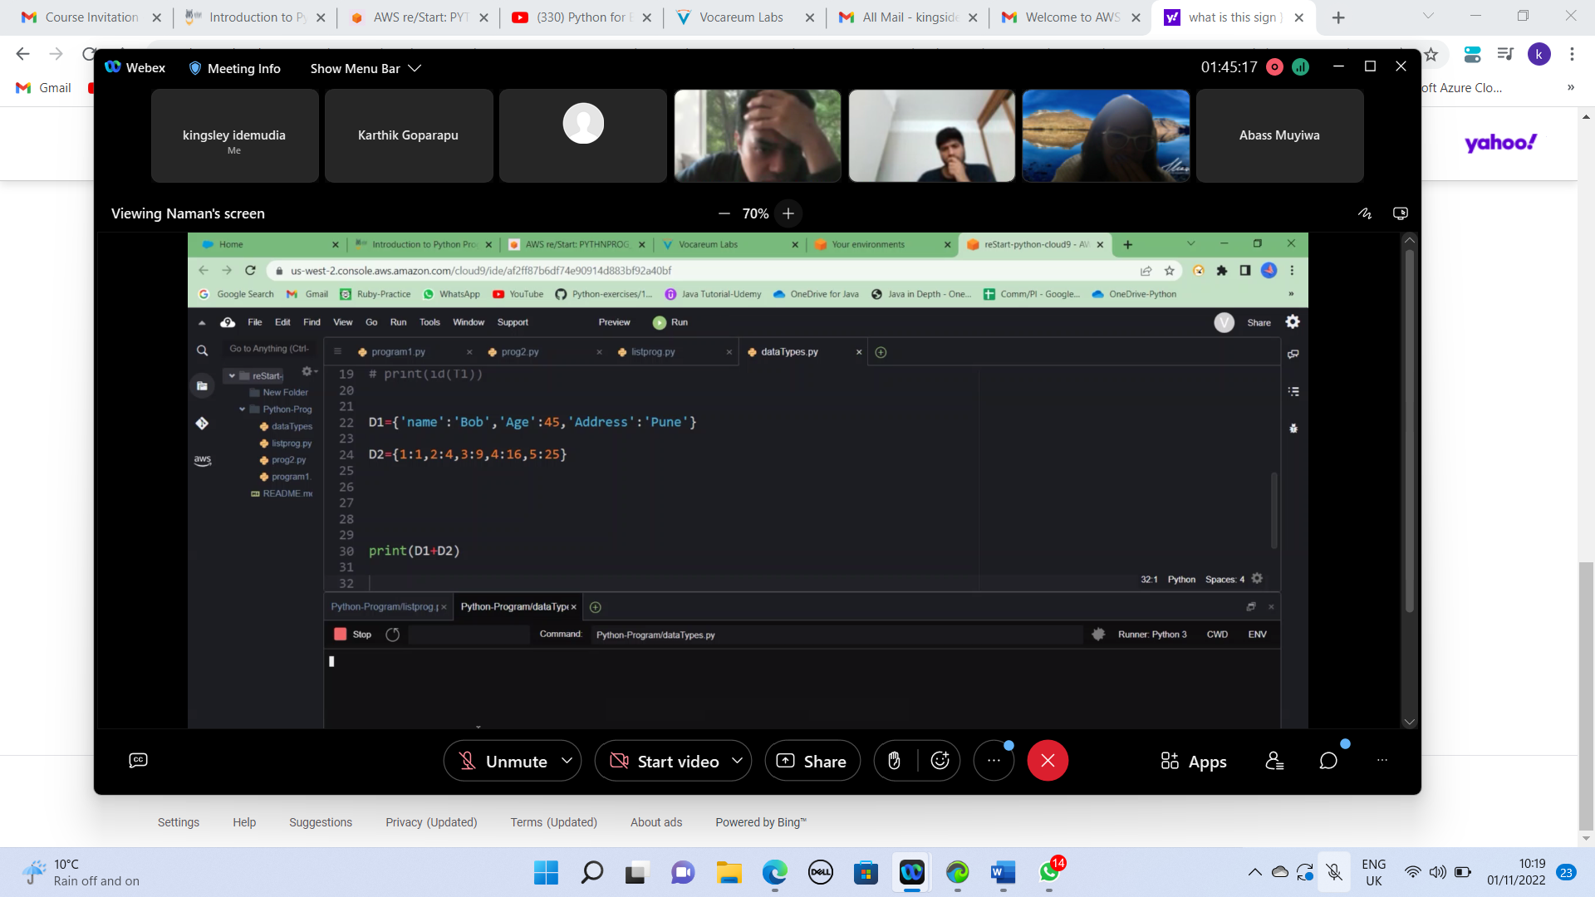

Print(T1\*3) display three times

Using the update function you two dictionary

D1 and D2

Elements that makes up the dictionaries are separated by coma

If you want to pick the key ( age, name, 45 etc)

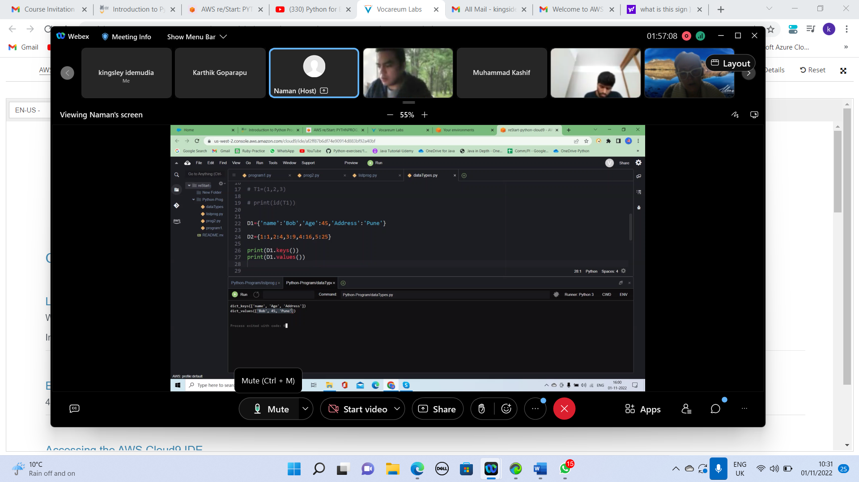

From lower case to upper case

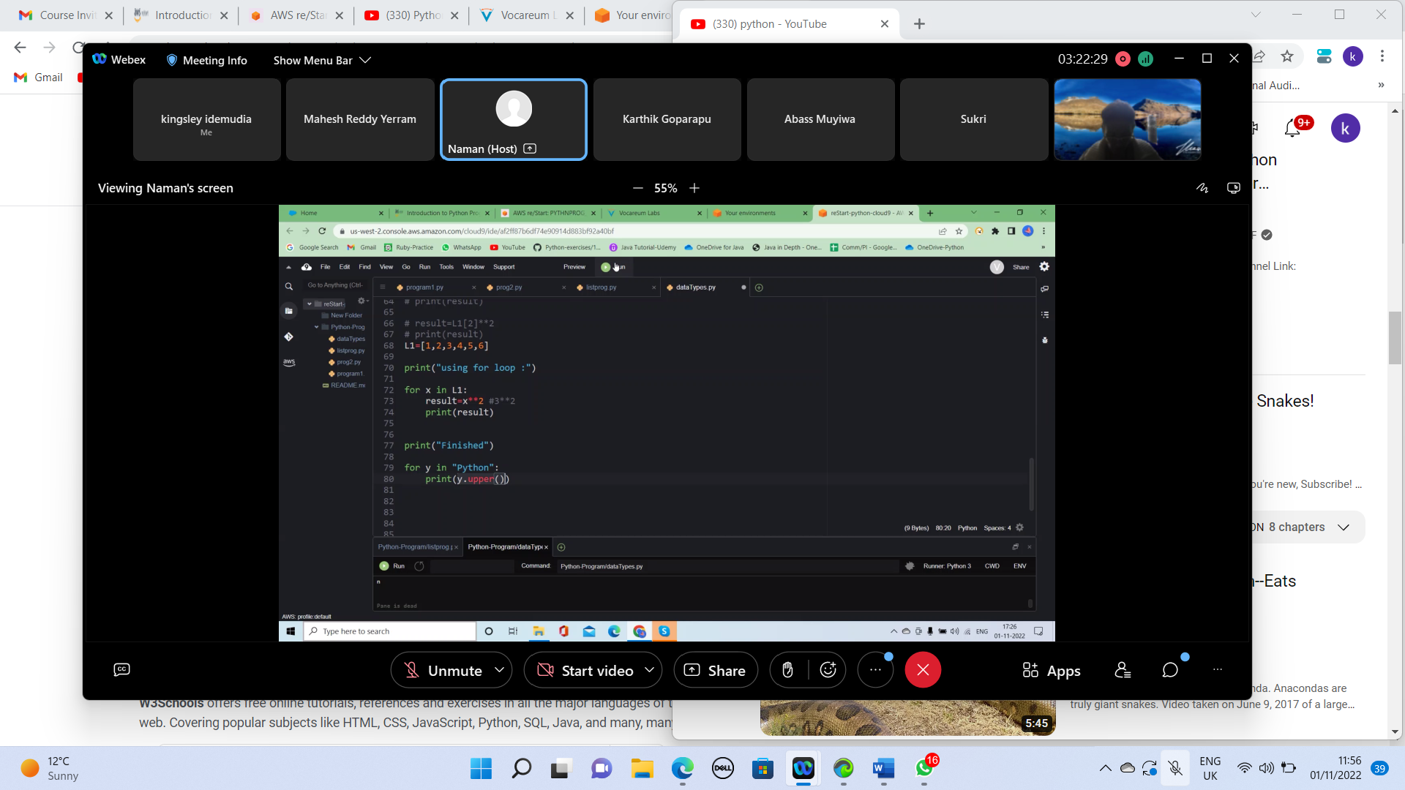

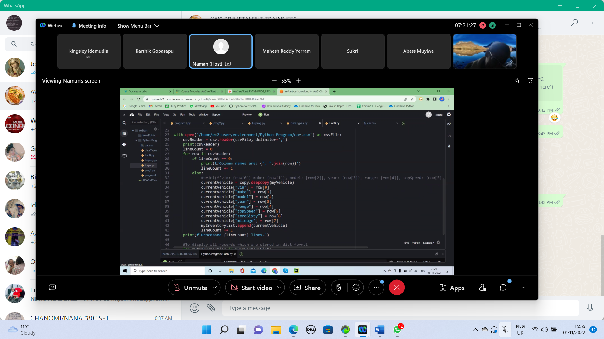

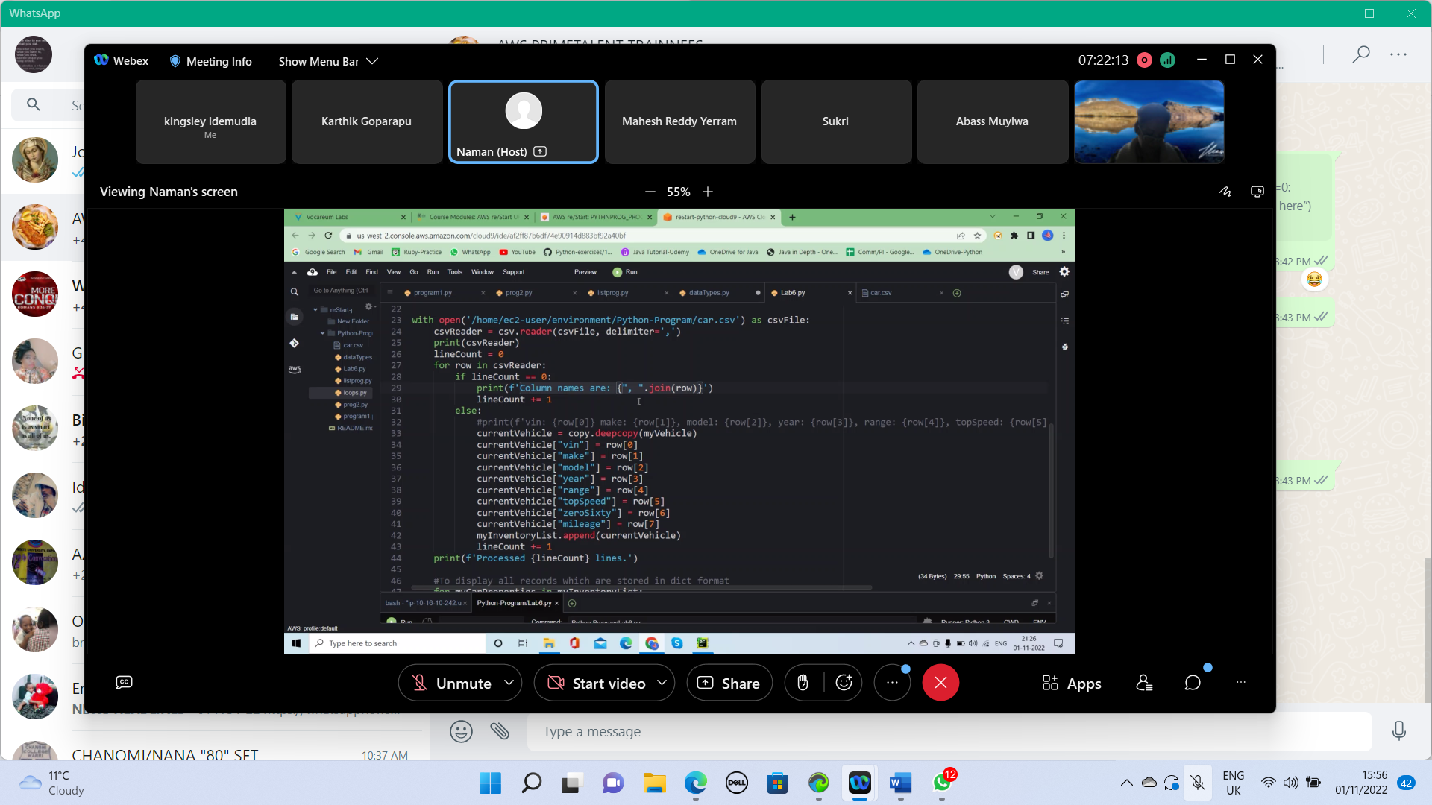

If is a conditional statement

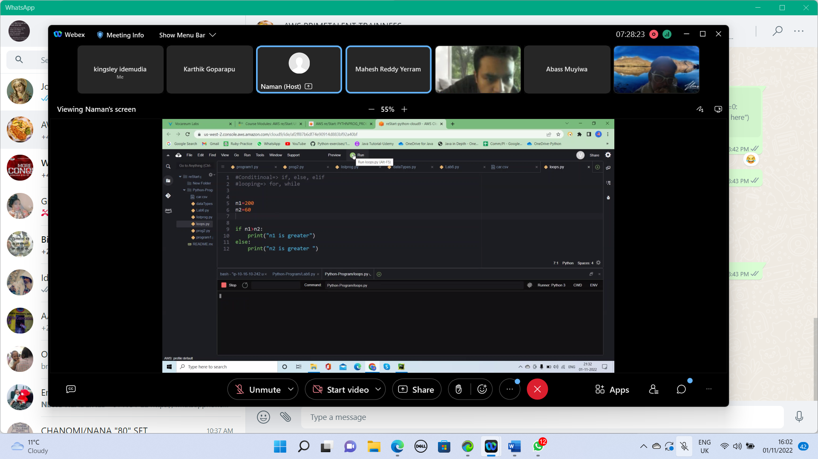

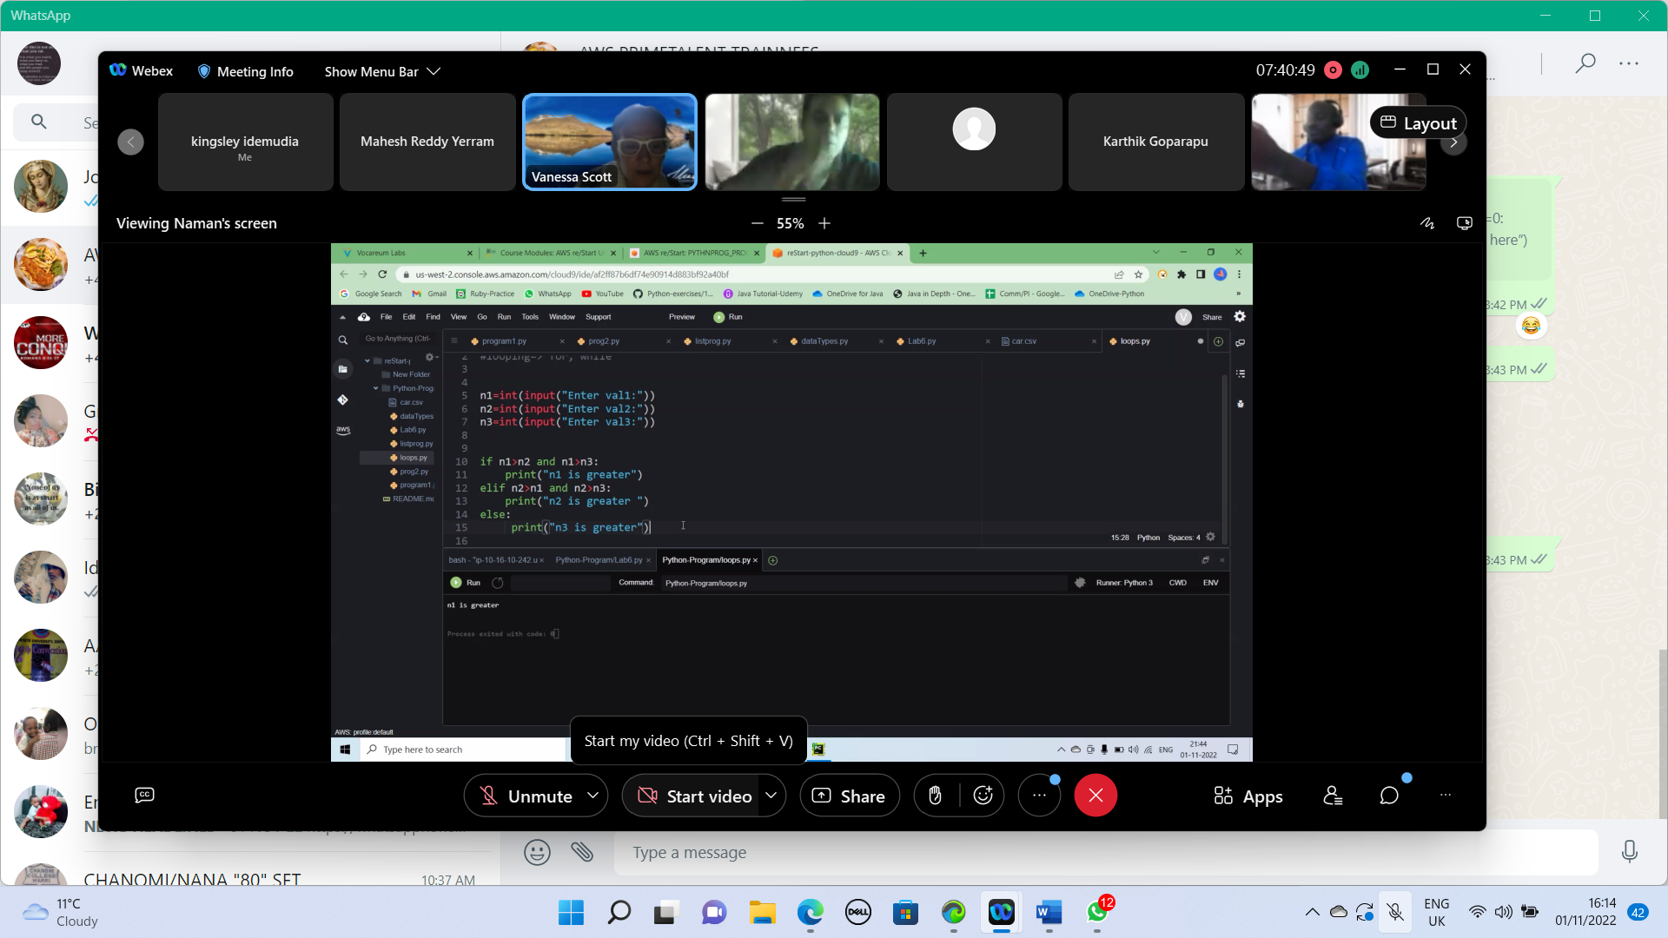

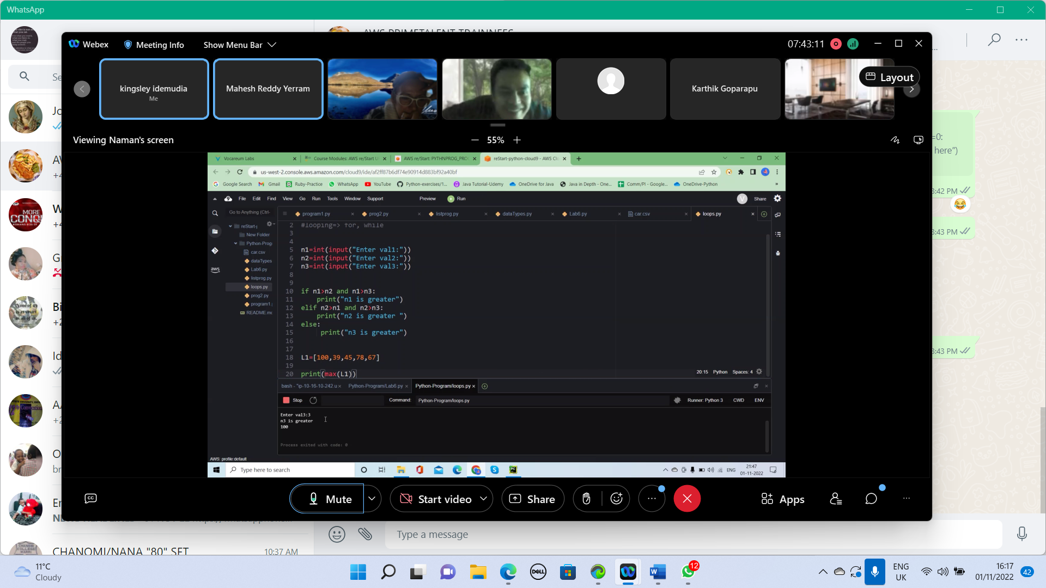



Write a program to create a list., and dispaly sum greatest and smallest element from list

from Naman to everyone: 5:09 PM

write a program to display sum of all numbers from list

write a program to read hours, minutes and convert Hours and Minutes into Seconds